Supporting Information for “Arctic Amplification: a Rapid Response to Radiative Forcing”
Michael Previdi^{1*}, Tyler P. Janoski^{1,2}, Gabriel Chiodo^{3,4}, Karen L. Smith^{1,5},
Lorenzo M. Polvani^{1,2,4}

¹Lamont-Doherty Earth Observatory of Columbia University, Palisades, NY 10964, USA.
²Department of Earth and Environmental Sciences, Columbia University, New York, NY 10027, USA.
³Institute for Atmospheric and Climate Science, Swiss Federal Institute of Technology Zurich, 8092 Zurich, Switzerland.
⁴Department of Applied Physics and Applied Mathematics, Columbia University, New York, NY 10027, USA.
⁵Department of Physical and Environmental Sciences, University of Toronto Scarborough, Toronto, Ontario, Canada M1C 1A4.
*e-mail: mprevidi@ldeo.columbia.edu

Contents of this file:

Figures S1-S3

Figure S1. Multimodel mean surface air temperature (SAT) response (in K) averaged over the first 3 months (January-March) of the CMIP5 simulations.

Figure S2. Annual mean stratosphere-adjusted radiative forcing (in W m⁻²) from 4CO₂ as computed by PORT.

Figure S3. Anomalous (i.e., Arctic minus global) warming contributions from feedbacks and energy transport responses for (a) the first 3 months (January-March), (b) the first year, and (c) the last 30 years of the CMIP5 simulations. Colored circles represent individual models, and horizontal bars are the multimodel means.

Figure S1.

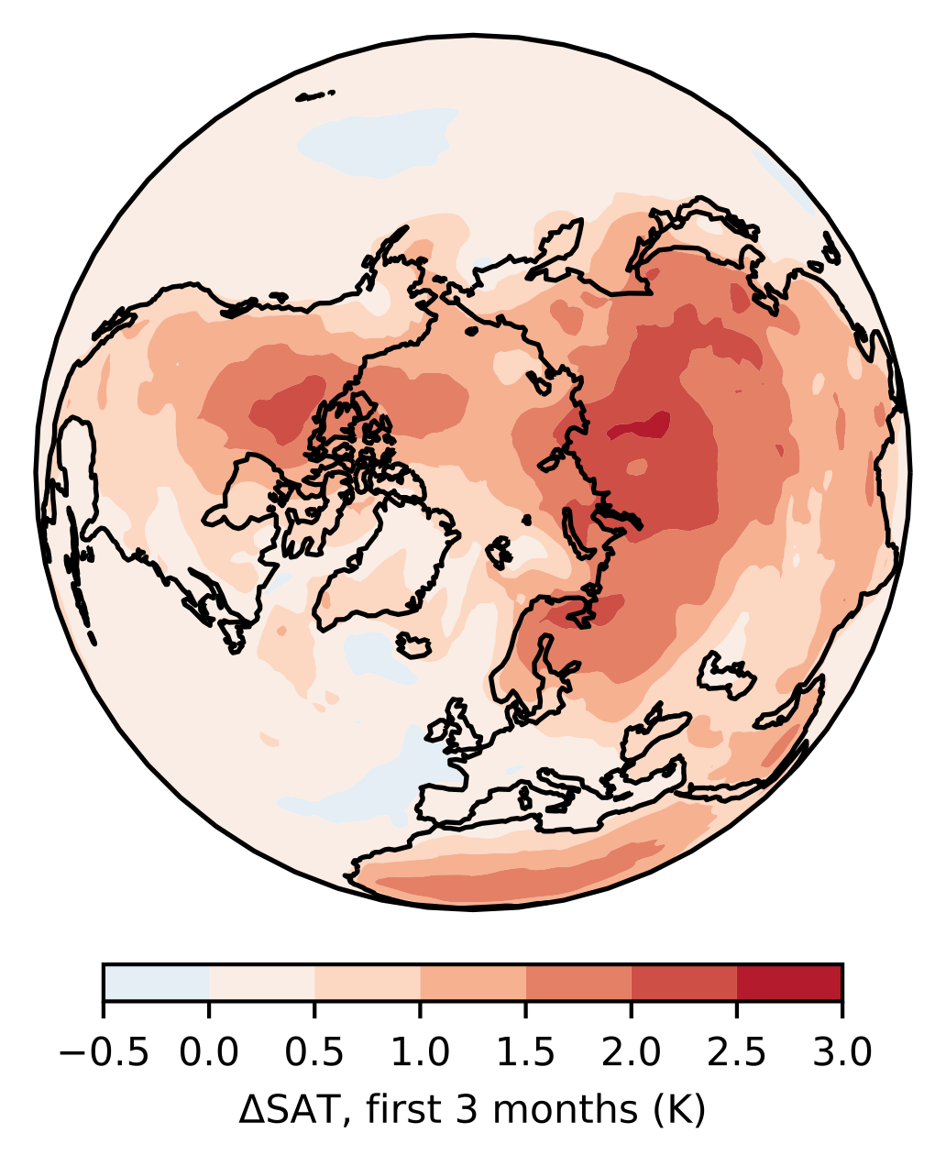

Figure S2.
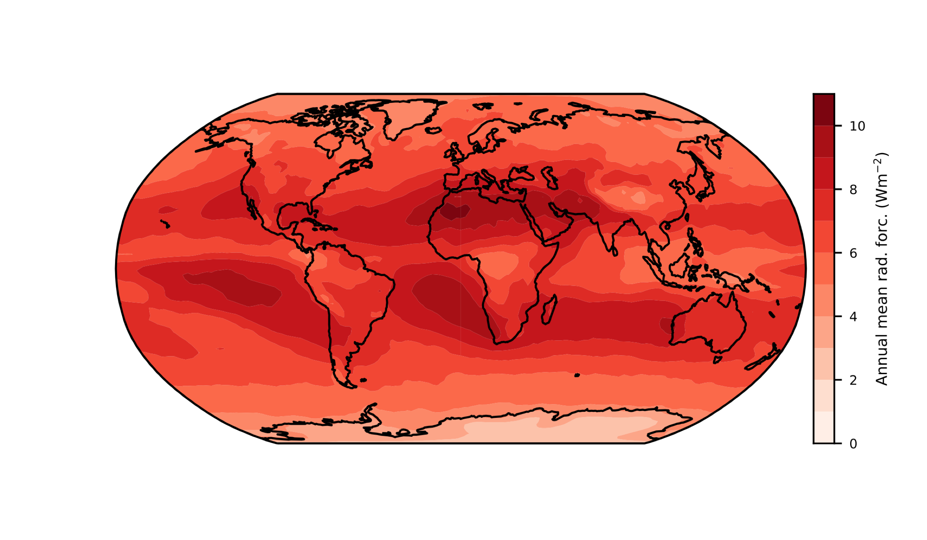

Figure S3.
